Group: 29

Team Members

|  |  |
| --- | --- |
| Martin Bath | Computer Science with AI |
| Tom Payne | Computer Science with Software Eng |
| Oliver Stevens | Computer Science with Gaming |
| Evan Ashby | Computer Science with Gaming |

**Main Client Bid**

Startup Bid (Priority) – “ Rulescard”

**Secondary Client Bid**

Startup Bid (2nd / 3rd Priorities) – “Wait 4 It” / “Craaash”

**Tertiary Client Bid**

Cairing Games Walk in the Park.

**Start-up Idea**

Introducing “Rulescard”, a card game app where the rules change for each game / during the game and you can play against another person or AI where there is a choice of whether the AI agent knows the rules or not. Through the subsequent rounds, the AI will attempt to learn the rules and win.

Common card rules e.g. Take one card, score points, aim to end up with an empty hand, will be selected to start the game and other rules can be added as the game progresses.

Games are to be saved / shared / retrieved online.

Team experiences – two gamers will aid the graphics and game play, AI interest will assist with the strategy and Computer Science will help with general programming methodologies and standards. Martin’s background in Project Management will aid with the overall progress of the team.

Diversity of the team will aid idea generation.

Appendices show the 3 game ideas in order of preference.

Appendix A

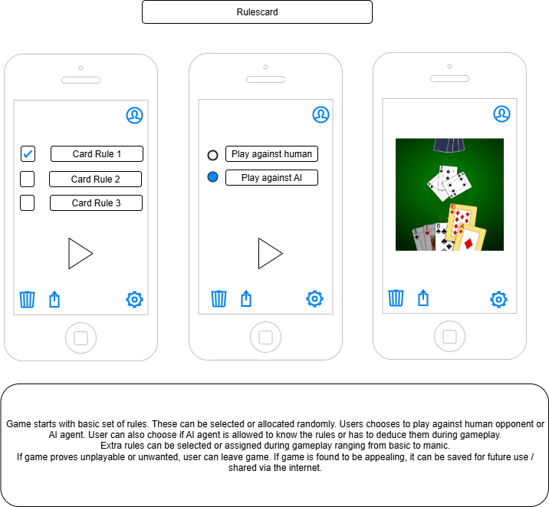

Appendix B

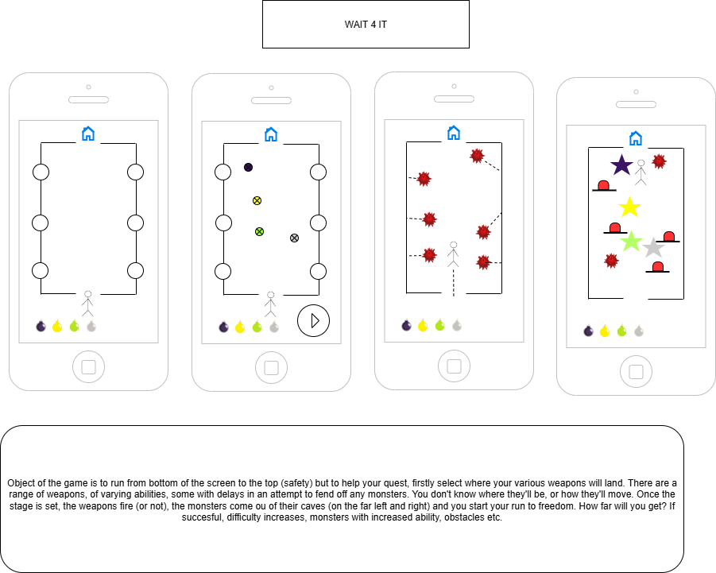

Appendix C

